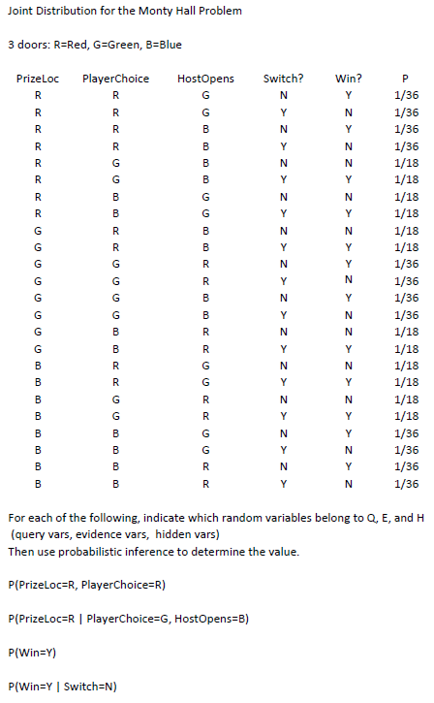

2/9

1/9

1/2

1/3

We assume Query variables are those whose marginals, conditionals, or probability subsets thereof are desired. Evidence variables are those having values given to limit the conditions under which query variable outcomes are considered, and Hidden variables are the remaining random variables in the table.